# Milestone 5 Updated Design and Near-Complete Implementation

### System Operations

* setSceneName
* addVolunteer
* removeVolunteer
* addEquipment
* removeEquipment
* addSCeneToScript
* getScenesInConflict
* selectAScene
* getVolunteersFromScene
* sendEmailToVolunteers
* sendUsernamePassword
* userValidated
* sendVolunteerInfo
* createNewVolunteer
* setVolunteerDetails
* addAvailability
* volunteerAdded
* getScript
* getScriptSchedule
* createSceneFilmingDate
* getSceneByName
* setfilmingDateSCene
* setTimeOfFilmingDate
* addFilmingDateToSChedule

### Sequence Diagrams

Add Filming Date To Schedule

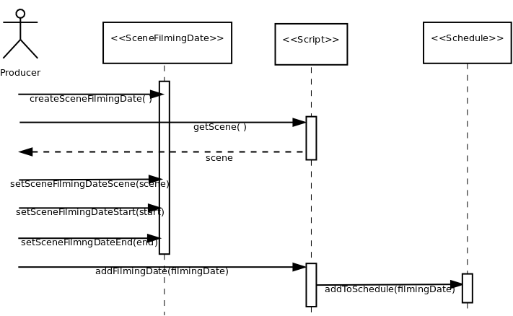

Add Scene

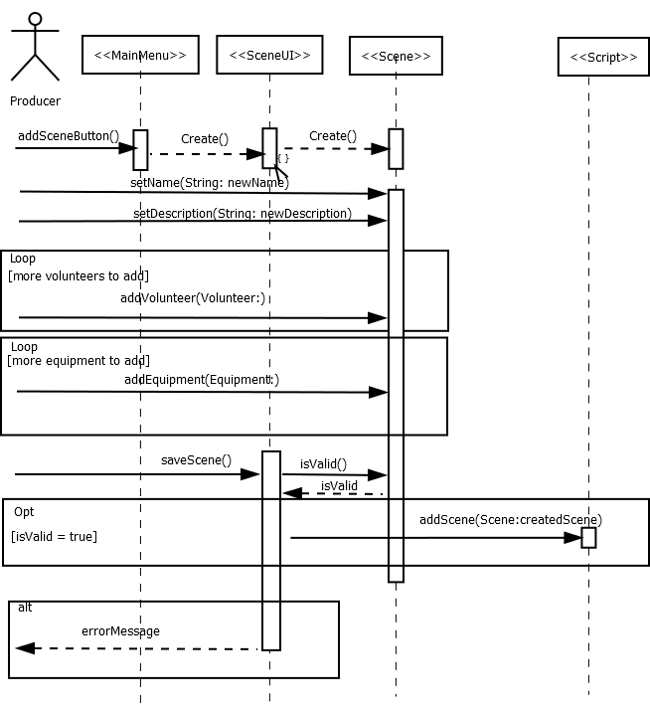

Add Volunteer

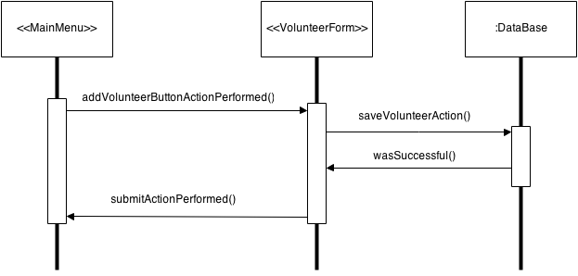

Send Email to volunteers in conflicted Scene

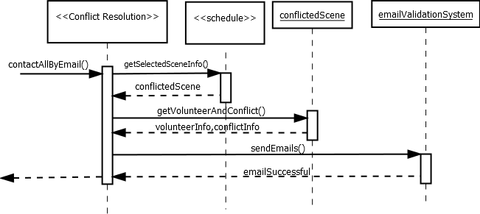

Volunteer Login

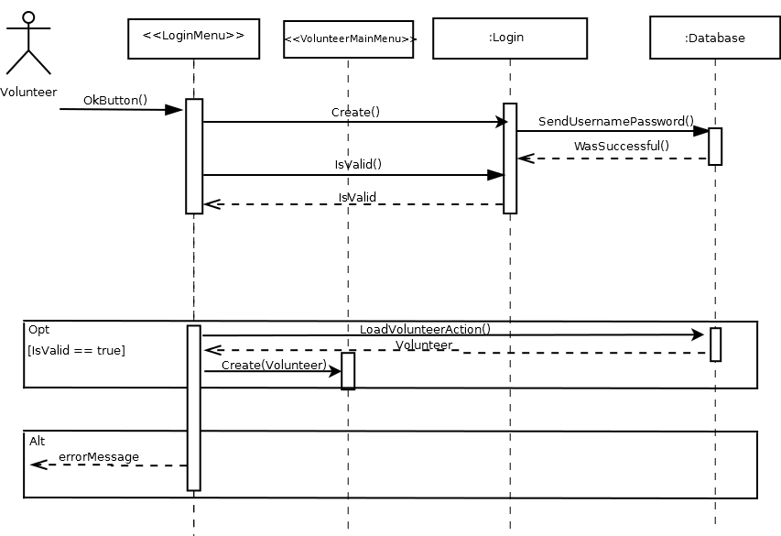

### Class diagram

See the ClassDiagram.png file in the hand in folder. It’s too big to display clearly in this document.

### Git Log

See the file entitled “gitlog.txt” in the submission folder!

### Meeting Minutes

**meeting minutes Nov 4th**

present: Mitchell, Iain, Ryan, John

time: 4:00-5:00

discussed milestone 5

all issues to be completed have been uploaded to issues on github

agreed on work allocation issues section on github

agreed on coding format (get and set)

agreed to implement cloneable (deep clone) and overwrite the original with the clone on a successful change

discussed possible database fails during the middle of a group of transactions

start with begin and if anything goes wrong you do a rollback and try again if success commit

discussed volunteer availabilities

discussed new main menu layout

discussed the possibility of using html within swing\java

time: 5:00-5:30 present: Mitchell, Iain, Ryan, John, Matt

discussed midterm

went over previous test

**meeting minutes Nov 18th**

present: Mitchell, Iain, Ryan, John, Matt

time: 4:00-5:00

discussed milestone 5

made class diagram

agreed on a pretty printing style

discussed grasp patterns

solidified success scenarios

### Project PLan

Milestone 5 Requirements:

|  |  |  |  |  |  |
| --- | --- | --- | --- | --- | --- |
| Requirement | Who? | Expected time | Real time | Completion Date | Completed? |
| Sequence Diagrams | All | 10h | 2h (ryan) | Oct 14th | Completed |
| Class Diagram | Iain | 3h |  | Nov 21st | Completed |
| Implementation | All | ~80h | 30hr(ryan) | Nov21st | Completed |
| Project Plan | Mitchell |  |  |  | Completed |
|  |  |  |  |  |  |

Implementation expectations:

|  |  |  |  |  |  |
| --- | --- | --- | --- | --- | --- |
| Implementation Goal | Who’s completed it for their section/Responsible | Expected time | Actual Time | Completion date | Completed? |
| Major Success Scenario | Matt/John/Ryan | 60-70h total | 80hr | Nov 21st | Completed |
| UI | Iain, Mitchell, Ryan, John | 20h total | 21h | “ | Completed |
| Naming Conventions | Iain,Ryan | 2h | 3 1/2hr | “ | Completed |
| Comments | All | 5h | 4h | “ | “ |
| Consistent Style | Iain | 4h | 2h | “ | “ |
| User Manual | Matt/Ryan | 2h | 2h | “ | “ |
| Git Log | Iain | A few minutes | A FEW SECONDS | “ | “ |

### % contribution

Iain –

Mitchell –

Matt –

Ryan –

John –

### Work required to complete the project

|  |  |  |  |  |  |
| --- | --- | --- | --- | --- | --- |
| What? | Who? | Expected Time | Actual Time | Required date | Completed? |
| Abstract | All | 1h |  |  |  |
| Intro(M2) | Mitchell | 2h |  |  |  |
| Requirements/Early Design(M3) |  | 2h |  |  |  |
| Updated design and Testing | All | 20h |  |  |  |
| Reengineering | All | 5h |  |  |  |
| Complete implementation (m5ish) | All | 20h |  |  |  |
| Project plan etc | Mitchell | 2h |  |  |  |
| Conclusion | Mitchel | 1h |  |  |  |